**Deployment Process:**

**Prerequisites**: Follow the below link for installing Minikube based on OS

<https://minikube.sigs.k8s.io/docs/>

Addons Minikube- Run minikube addons enable ingress for enabling ingress.

Create manifest files for application deployment under minikube.

Note: I created deployment of application using manifest yml files and Helpcharts.

**Output Verification:**

Based on the requirement all resources created under sre-techtask name space.

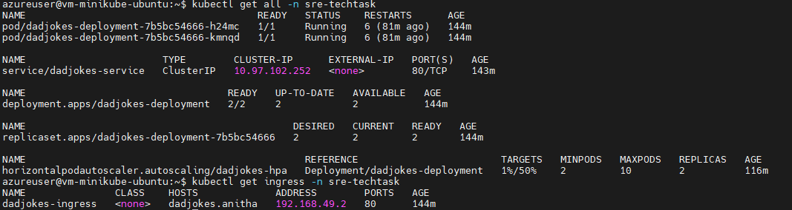

All manifest files has been attached.



Step1: Application deployed by invoking a single command.PFB screenshot FYI

sh dadjokesdeploy.sh

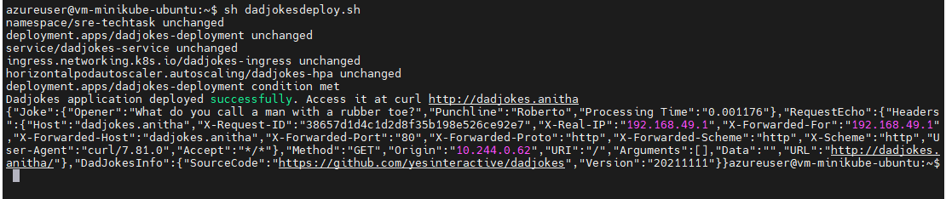

Steps2: All pods are running and stable. PFB screenshot FYI.

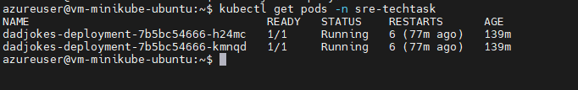

Step3: Application is accessible from the host machine via URL. PFB screenshot FYI.

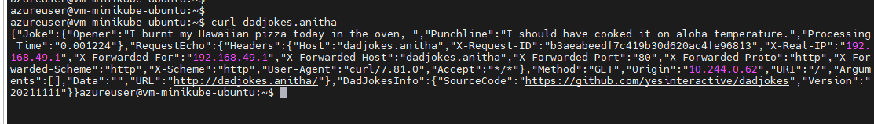

**Deployment process using Helm chart:**

Install helm package manager using <https://helm.sh/docs/> document.

**Helm create <chart-name>**

Ex: Helm create dadjokes-hem

Updated/Modified necessary changes inside the template folder yaml files and values file as well.

Fir the first time use belo command  
 helm install <release-name> <chart-name> -n <namespace>

Ex: helm install dk dadjokes-helm –n sre-techtask

To verify the helm chart completed or nor run belo command

**helm ls –n <namespace>**

**For any update/upgrade/releases use below command**

**helm upgrade dk dadjokes-chart –n sre-techtask  
Before accessing application I updated hosts file with minikube ip URL in the ingress file name.**

**After the successful deployment application should be accessible with URL.PFB for your reference.**

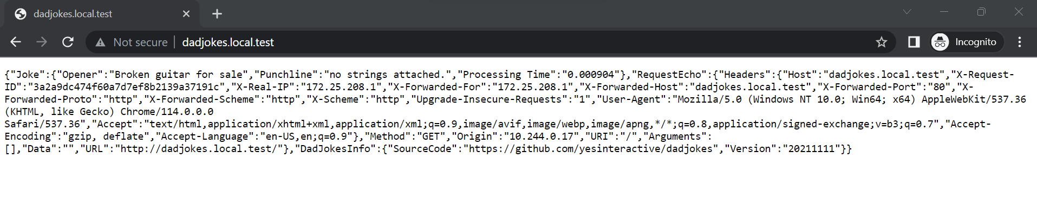

Note: If we want to expose the deployment we need expose with nodeport or loadbalancer using below command or change the type in service file.

**-to expose the deployment**

#kubectl expose deployment dadjokes-deployment --type=NodePort

kubectl expose deployment dadjokes-deployment --type=Loadbalancer

-then expose the service

kubectl port-forward svc/dadjokes-service 8100:8100 --address 0.0.0.0 &

Github URL for review code: <https://github.com/Anitha1214/>